**Plasma Spray Coating Research for Pratt and Whitney by Max Plomer**

**Summary:** The following is a preliminary research of the Plasma Spray Coating process; we will review basic heat transfer material and then build a simple analytical/numerical estimate of the location of a particle when it has reached melting temperature and then when it has fully melted. There are 3 main problems that are combined into the solution:

(1) Lumped capacitance model is used for low Biot number spheres being heated to melting temperature

(2) Once particle reaches melting temperature this becomes a Stefan Problem where we calculate the particle’s solid fraction using it’s latent heat of melting

(3) Linear and quadratic drag coefficients are used to calculate the location of the particle when melted.

**Sources for the following material is:**

1. MIT material processing lecture notes part of the MIT Open Courseware initiative

2. Classical Mechanics. John R. Taylor

3. Fundamentals of Heat and Mass Transfer. Incropera, DeWitt, Bergman and Lavine

4. “Scaling Analysis and Prediction of Thermal Aspects of the Plasma Spraying Process Using a Discrete Particle Approach” Jinho Lee and Theodore L. Bergman

**Fourier’s Law**

$$\vec{q}=-k\vec{∇}T$$

$$\vec{q}=heat flux \left[\frac{J}{m^{2} s}=\frac{W}{m^{2}}\right] k=thermal conductivity \left[\frac{W}{m K}\right]$$

**Heat Balance in Small Element**

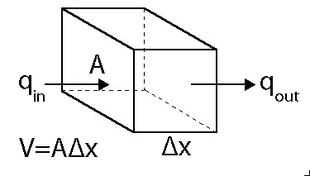

heat in – heat out + heat generation (chemical reaction) = heat accumulation

$$Aq_{in}-Aq_{out}=V\frac{∂H}{dt} H=enthalpy per unit volume$$

$${\left[q\right]}_{x}-{\left[q\right]}_{x+∆x}=∆x\frac{∂H}{dt}$$

$$\frac{\left({\left[-k\frac{∂T}{dt}\right]}_{x}-{\left[-k\frac{∂T}{dt}\right]}_{x+∆x}\right)}{∆x}=\frac{∂H}{dt}$$

Limit as $∆x→0$

$$\frac{∂}{dx}\left(k\frac{∂T}{dx}\right)=\frac{∂H}{dt}$$

If k is constant

$$k\frac{∂^{2}T}{dx^{2}}=\frac{∂H}{dt}$$

From definition of heat capacity at constant pressure

$$ρc_{p}=\frac{∂H}{∂T}$$

Divide by $∂t$

$$\frac{∂H}{∂t}=ρc_{p}\frac{∂T}{∂t}=k\frac{∂^{2}T}{dx^{2}}$$

**Heat Conduction Equation**

$$\frac{∂T}{∂t}=α\frac{∂^{2}T}{dx^{2}}$$

$$α=thermal diffusivity=\frac{k\left[\frac{W}{m*K}\right]}{ρ\left[\frac{kg}{m^{3}}\right] c_{p}\left[\frac{J}{K*kg}\right]}=\left[\frac{m^{2}}{s}\right]$$

Assumes $k≠f(x)$

$$ρc_{p}\frac{∂T}{∂t}=\vec{∇} ∙ k\vec{∇}T went to \frac{∂T}{∂t}=α{\vec{∇}}^{2}T$$

**Steady State 1D Conduction**

$${\vec{∇}}^{2}T=0 Laplace Equation$$

$$1D \frac{∂^{2}T}{dx^{2}}=0 (a line)$$

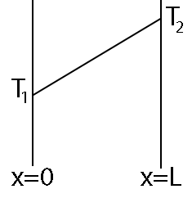

$$\int{\left[\frac{d}{dx}\left(\frac{dT}{dx}\right)=0\right]}dx$$

$$\int{\left[\frac{dT}{dx}=A\right]}dx$$

$$T=Ax+B$$

At x=0, T=T1

At x=L, T=T2

Dimensionless variables T* and x

$$T^{*}=\frac{T-T_{1}}{T_{2}-T_{1}} x^{*}=\frac{x}{L} T^{*}=x^{*}$$

*

Constant heat flux

$$q=-k\frac{dT}{dx} \frac{dT}{dx}=\frac{T_{2}-T_{1}}{L}$$

**Steady State in Cylinder**

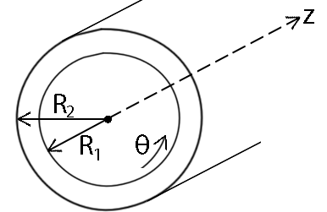

$${\vec{∇}}^{2}T=0$$

$$\frac{1}{r}\frac{∂}{∂r}\left(r\frac{∂T}{∂r}\right)+\frac{1}{r^{2}}\frac{∂^{2}T}{∂θ^{2}}+\frac{∂^{2}T}{∂z^{2}}=0$$

T constant in z and $θ$ directions

$$\frac{1}{r}\frac{d}{dr}\left(r\frac{dT}{dr}\right)=0$$

$$\int{\left[\frac{d}{dr}\left(r\frac{dT}{dr}\right)=0\right]}dr$$

$$r\frac{dT}{dr}=A$$

$$\int{\left[\frac{dT}{dr}=\frac{A}{r}\right]}dr$$

Note:

At r=R1, T=T1

At r=R2, T=T2

From eq1

$$B=T_{1}-Aln\left(R_{1}\right)$$

From eq2

$$B=T_{2}-Aln\left(R_{2}\right)$$

Substitute eq2 $→$ eq1

$$T_{1}-Aln\left(R_{1}\right)=T_{2}-Aln\left(R_{2}\right)$$

$$T_{1}-T_{2}= Aln\left(R_{1}\right)-Aln\left(R_{2}\right)=Aln\left(\frac{R_{1}}{R_{2}}\right)$$

$$A=\frac{T_{1}-T_{2}}{ln\left(\frac{R_{1}}{R_{2}}\right)} B=T_{1}-\frac{T_{1}-T_{2}}{ln\left(\frac{R_{1}}{R_{2}}\right)}ln\left(R_{1}\right)$$

$$T=\frac{T_{1}-T_{2}}{ln\left(\frac{R_{1}}{R_{2}}\right)}ln\left(r\right)+T_{1}-\frac{T_{1}-T_{2}}{ln\left(\frac{R_{1}}{R_{2}}\right)}ln\left(R_{1}\right)$$

Subtract T1, divide by (T1-T2)

Dimensionless variable T

$$T^{*}=\frac{T-T_{1}}{T_{2}-T_{1}}=\frac{\ln\left(\frac{r}{R_{1}}\right)}{\ln\left(\frac{R_{2}}{R_{1}}\right)}$$

*

Constant total heat flux, but flux not constant

$$q=-k\frac{dT}{dr}≠constant$$

$$A=2πr qA=constant$$

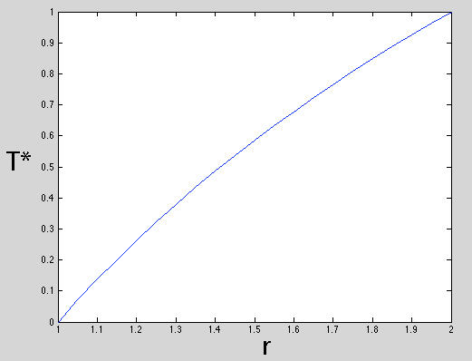

At r=1 T=T1

At r=2 T=T2

**Steady State in Composite Wall**

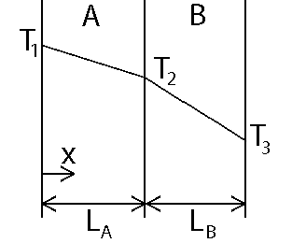

T2 is unknown

At x=LA, T=T2, qin=qout

Useful conclusions

$$\frac{∆T_{A}}{∆T_{B}}=\frac{ \frac{L_{A}}{k_{A}} }{\frac{L_{B}}{k_{B}}}$$

$$q=-k\frac{∆T}{L} → ∆T∝\frac{L}{k}$$

Thermal circuit

$$R_{cond,A}=\frac{L_{A}}{k_{A}} R_{cond,A}=\frac{L_{B}}{k_{B}} q=\frac{T_{1}-T_{3}}{\frac{L_{A}}{k_{A}}+\frac{L_{B}}{k_{B}}}$$

Note: since $q=-k\frac{∂T}{dx}$, we can use the q from the thermal circuit to go directly to the temperature gradient

$$\frac{∂T}{dx}=\frac{-q}{k}$$

Comparison of Steel vs. Mullite

$$k_{Steel}=30\frac{W}{m K} k_{Mullite}=3\frac{W}{m K}$$

$$if L_{Steel}=L_{Mullite}, \frac{∆T_{Mullite}}{∆T_{Steel}}=10$$

**Steady State Convection on Wall**

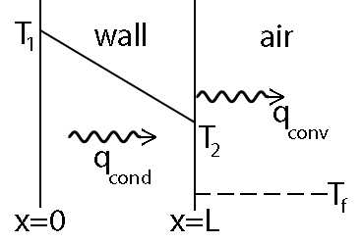

T2 is unknown

At x=L

$$q=h\left(T_{2}-T_{f}\right)$$

$$h=convection heat transfer coefficient \left[\frac{W}{m^{2} K}\right]$$

$$q=heat flux \left[\frac{W}{m^{2}}\right]$$

$$\frac{∂^{2}T}{dx^{2}}=0 in wall T=T_{1}+\frac{T_{2}-T_{1}}{L}x$$

At x=L, qcond=qconv

Dimensionless variables T* and x

$$T^{*}=\frac{T-T_{1}}{T_{f}-T_{1}} x^{*}=\frac{x}{L} T^{*}=x^{*}\left[\frac{1}{1+\frac{k}{hL}}\right]$$

*

Thermal circuit

$$R_{cond}=\frac{L}{k} R_{conv}=\frac{1}{h} q=\frac{T_{1}-T_{f}}{\frac{L}{k}+\frac{1}{h}}$$

$$Biot Number=B_{i}=\frac{hL}{k}=ratio of conductive resistence to convective$$

Bi<<1

-Slow convection, no temperature gradients in solid

Bi $≈$ 1

-Conduction and convection equally important, transient solution

Bi>>1

-T2=Tf, rapid convection

**1D Plane Wall Conduction with Convection on Both Sides**

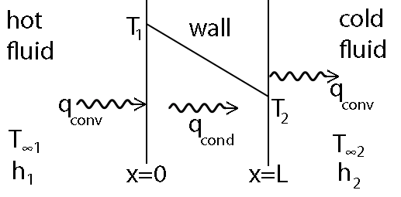

T1 and T2 are unknown, assuming k is constant otherwise $\frac{d}{dx}\left(k\frac{dT}{dx}\right)=0$

$$\frac{∂^{2}T}{dx^{2}}=0 in wall T=Ax+B$$

At x=0, qcond = qconv  At x=L, qcond=qconv

Solve for A

$$-kA=Ah_{2}\left(L+\frac{k}{h_{1}}\right)+h_{2}\left(T_{∞1}- T_{∞2}\right)$$

$$A\left(-k-h_{2}\left(L+\frac{k}{h_{1}}\right)\right)=h_{2}\left(T_{∞1}- T_{∞2}\right)$$

$$A=\frac{h_{2}\left(T_{∞1}- T_{∞2}\right)}{-k-h_{2}\left(L+\frac{k}{h_{1}}\right)}=\frac{-\left(T_{∞1}- T_{∞2}\right)}{k\left(\frac{1}{h_{1}}+\frac{1}{h_{2}}+\frac{L}{k}\right)}$$

$$B=\frac{kA}{h_{1}}+T_{∞1}$$

$$q=-k\frac{dT}{dx}=-kA$$

Thermal circuit

$$R_{cond}=\frac{L}{k} R_{conv1}=\frac{1}{h_{1}} R_{conv2}=\frac{1}{h_{2}} q=\frac{T_{∞1}-T_{∞2}}{\frac{L}{k}+\frac{1}{h_{1}}+\frac{1}{h_{2}}}$$

**Low Biot Number Solutions**

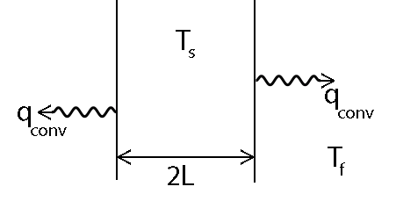

Global heat balance, $T=f(t)$

$$Ah\left(T-T_{f}\right)=-ρc_{p}\frac{dT}{dt}V$$

Separation of variable

$$\int{\frac{-Ah}{ρc_{p}V}dt}=\int{\frac{1}{T-T_{f}}}dT$$

Note: Integrate RHS using u-substitution,

$$u=T-T_{f}, du=dT, \int{\frac{1}{T-T_{f}}}dT=\ln\left(u\right)+C$$

$$\frac{-Ah}{ρc_{p}V}t+C=\ln\left(T-T_{f}\right)$$

At t=0, T=Ts

$$C=\ln\left(T_{s}-T_{f}\right)$$

$$\frac{-Ah}{ρc_{p}V}t=\ln\left(T-T_{f}\right)-\ln\left(T_{s}-T_{f}\right)=\ln\left(\frac{T-T_{f}}{T_{s}-T_{f}}\right)$$

$$\frac{T-T_{f}}{T_{s}-T_{f}}=\exp\left(\frac{-Ah}{ρc_{p}V}t\right)$$

**Thermal Spray Coatings / Plasma Spray**

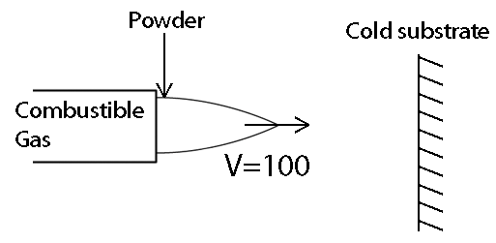

Spray is quasi-steady state because it is assumed that neither the plasma torch nor substrate moves with respect to the other, and that the particle is heated isothermally. This assumption is justified with Bi << 1 .

oxyacetylene torch: T = 3000K

powder: Ni alloy MAR-M200 R = 2 – 50 $μm$ ($μm={10}^{-6}m$)

Problem: need to find time that spherical particle reaches melting temperature Tm

At r=0, symmetry $\frac{∂T}{∂r}=0$

At r=R convection into ambient air, $q=h\left(T-T_{f}\right) T_{f}=3000K h≈500\frac{W}{m^{2} K}$

Governing equations

$$Bi=\frac{hL_{c}}{k}$$

Lc is the character length defined as volume/area ratio, R/3 for sphere, L for wall of thickness 2L, R/2 for cylinder

$$h=500 \frac{W}{m^{2} K} R=50*{10}^{-6}m k=16\frac{W}{m K}$$

$$Bi=\frac{h R}{k 3}=5.2*{10}^{-4}≪1 Can use lumped capacitance model$$

$$\frac{T-T_{f}}{T_{0}-T_{f}}=\exp\left(\frac{-Ah}{ρc_{p}V}t\right)$$

$$\frac{V}{A}=\frac{\frac{4}{3}πr^{3}}{4πr^{2}}=\frac{R}{3}$$

Time to reach melting temperature

$$t_{1}=\ln\left(\frac{T_{m}-T_{f}}{T_{0}-T_{f}}\right)\frac{-ρc_{p}R}{h 3}=0.1035 s$$

$$T_{f} = 3000K T_{0}=300K h=500 \frac{W}{m^{2} K}$$

$$ρ=8500\frac{kg}{m^{3}} c_{p}=500\frac{J}{kg K} T_{m,Ni}=1700K$$

Once particle gets to melting temperature, still need to transfer energy to melt it

During heating:

$$Ah\left(T-T_{f}\right)=-ρc_{p}\frac{dT}{dt}V$$

During melting:

$$Ah\left(T_{m}-T_{f}\right)=ρVh_{sf}\frac{df_{s}}{dt}$$

$$f_{s}=particle^{'}s solid fraction h_{sf}=particle^{'}s latent heat of melting$$

$$h_{sf,Ni}=297*{10}^{3}\frac{J}{kg}$$

$$Ah\left(T_{m}-T_{f}\right)=ρVh_{sf}\frac{df_{s}}{dt}$$

Separation of variable

$$\int{\frac{Ah\left(T_{m}-T_{f}\right)}{ρVh_{sf}}}dt=\int{df_{s}}$$

$$f_{s}=\frac{Ah\left(T_{m}-T_{f}\right)}{ρVh_{sf}}t+C$$

At t=0, fs=1, C=1

$$\frac{V}{A}=\frac{R}{3}$$

Want time when fs=0

$$t_{2}=\frac{-ρVh_{sf}}{Ah\left(T_{m}-T_{f}\right)}=\frac{-ρRh_{sf}}{3h\left(T_{m}-T_{f}\right)}=0.0647 s$$

Add time to reach Tm and time to melt to get total time

$$t_{tot}=0.1683 s$$

**Calculating Acceleration and Velocity of Particle Using Air Resistance**

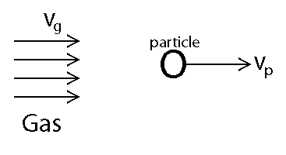

For speeds not approaching the speed of sound

$$f_{drag}=f_{lin}+f_{quad}=bv+cv^{2}$$

For spherical projectile b and c have the form

$$b=βD c=γD^{2}$$

For air at standard temperature ($0℃$) and pressure (1 atm), which is inaccurate but they were the values that were available

$$β=1.6*{10}^{-4}\frac{N s}{m^{2}} γ=0.25 \frac{N s^{2}}{m^{4}}$$

We can compare flin and fquad to see if one can be neglected, using v=100m/s and $D=100*{10}^{-6}m$

$$\frac{f_{quad}}{f_{lin}}=\frac{γD^{2}v^{2}}{βDv}=\frac{γDv}{β}=15.625$$

Quadratic is dominant at v=100m/s but it’s dominance diminishes as the particle gets up to speed, for the sake of completeness we will solve using both linear and quadratic drag.

From F=ma

$$\frac{dv}{dt}=\frac{b}{m}\left(v_{g}-v\right)+\frac{c}{m}\left(v_{g}-v\right)*abs\left(v_{g}-v\right)$$

$$m=Vρ=\frac{4}{3}πr^{3}ρ v_{g}=100\frac{m}{s} γ=0.25 \frac{N s^{2}}{m^{4}} c=γD^{2}$$

$$β=1.6*{10}^{-4}\frac{N s}{m^{2}} b=βD$$

$$D=100*{10}^{-6}m R=50*{10}^{-6}m ρ=8500\frac{kg}{m^{3}}$$

I chose to solve this numerically using Matlab

At $t=0.1683 s$ distance traveled is 13.1060 m

Code used:

function velocity_using_quadandlinear_drag

roe=8500;

R=50e-6;

D=2*R;

gamma=0.25;

beta=1.6e-4;

c=gamma*D^2;

b=beta*D;

V=4/3*pi*R^3;

m=roe*V;

vg=100;

%initial conditions

v0=0;

%time span 0 to 10 sec

tspan = [0 .1683];

[t ,v] = ode15s(@quaddrag, tspan, v0);

%calculate distance

distance=trapz(t,v)

function dvdt = quaddrag(t, v)%time, mass faction

dvdt = b/m*(vg-v)+c/m*(vg-v)*abs(vg-v);

end

end